

# Table of Contents

Table of Contents 2

Lesson Plan 4

BACKGROUND AND RATIONALE 5

OBJECTIVE 1: 7

Dragon and Internet Explorer Configuration 7

Configure Dragon for Use with Web-Based Applications 7

OBJECTIVE 2: 12

Effectively Navigate Internet Explorer by Voice 12

Navigation Command Summary 12

OBJECTIVE 3 16

Effectively Dictate Web Addresses in the Address Bar 16

Dictating Web Addresses 16

Objective 4 18

Effectively Utilize Favorites to Navigate to Frequently used Web Addresses 18

Utilizing Favorites 18

Objective 5 21

Effectively Utilize Tabbed Browsing 21

Utilize Tabbed Browsing to Open Multiple Web Pages within the Same Browser Window 21

Objective 6 24

Perform Search of the Web 24

Utilize Dragon to Perform a Web-based Search 24

EXHIBIT 1 – phonetic alphabet 25

Exhibit 2 – General User tips 26

FEEDBACK SHEET 27

# Lesson Plan

#### Lesson Objectives

At the completion of this lesson, you will be able to:

1. Configure Dragon NaturallySpeaking ("Dragon") for use with Web-based applications.
2. Use Dragon to successfully navigate standard Web pages.
3. Effectively dictate Web addresses ("URLs") in the Address Bar.
4. Effectively utilize Favorites to navigate to frequently used Web addresses.
5. Utilize tabbed browsing to open multiple Web pages within the same browser window.
6. Utilize Dragon to perform a Web-based search of the Internet.

#### Length of Lesson

2 hours

# BACKGROUND AND RATIONALE

Dragon NaturallySpeaking is "speech recognition" software that is available to assist employees who have a broad range of upper body mobility impairments that restrict their ability to use a mouse or keyboard. Dragon speech recognition reduces the pain and frustration of daily computer tasks by helping reduce the number of keystrokes and mouse clicks needed to manage computer applications – all by voice commands.

#### Dragon User Tips

In addition to reviewing the **User Tips** provided throughout this user guide, new Dragon NaturallySpeaking users may find it beneficial to review the **General User Tips** section, located in **Exhibit 2**, prior to continuing with this guide.

#### Utilizing Optional/Alternative Command Language

More often than not, there are multiple voice commands you may use to perform the same task with Dragon. Please review the table below for an explanation of how this user guide indicates optional or alternative language.

| **Symbol** | **Action** | **Description** |
| --- | --- | --- |
| **[ ]** | Indicate Optional statements | Brackets indicate Optional statements: [ ]. Optional statements are parts of the command you do not have to say for the command to work. For example, in the command "[**go to|switch to|view|display|show|open**] **Add to Favorites**," the only words that are required for the command to work are "**Add to Favorites**." "**Go to**," "**switch to**," "**view**," "**display**," "**show**," and "**open**" are optional. |
| **( )** | Indicate Alternative (i.e., Or) statements | Parentheses indicate alternative (i.e., Or) statements: ( ). Or statements designate a number of alternative commands and are usually preceded or followed by other commands. Or statements are shown by a separator bar, |, usually enclosed by parentheses. For example, the command "**(go to|switch to) folder**" indicates that the user may say, "**go to folder**" or "**switch to folder**." |
| **|** | Separate alternative language | The separator bar, |, is used to separate alternative language in both Or statements and Optional statements. |
| **< >** | Indicate lists | Lists are indicated by left and right angle brackets: < >. In this user guide, left and right angle brackets < > are used to indicate either a specific list used by the command, or may be used to indicate a variable. For example, in the command "**move down <1-20> lines**," **<1-20>** indicates that the user may select any number of lines from 1 to 20. |

Table 1: Symbols Indicating Optional or Alternative Command Language

#### SSA Web-based Applications

In general, Dragon commands for use in the Internet are the same commands utilized in SSA Web-based applications on the SSA Intranet. It is important for the user to note, however, that Dragon is not entirely consistent within the SSA Intranet.

# OBJECTIVE 1:

## Dragon and Internet Explorer Configuration

### Configure Dragon for Use with Web-Based Applications

#### Overview

The **Commands** tab of the **Options** dialog box allows you to enable commands in HTML windows and determines whether you are required to "**click**" to select hyperlinks in HTML windows.

#### Commands Options

Access Dragon NaturallySpeaking Commands Options (See Figure 1):

* + Say, "**switch to DragonBar**."
  + Say, "**Tools**."
  + Say, "**Options**."
  + Say, "**Commands**."

**Enable HTML support** checkbox should be checked. Checking this allows you to use commands designed specifically for Internet Explorer. Any change to this option does not take effect until you restart Dragon and then start Internet Explorer. If the checkbox is not checked, say, "**Enable HTML support**" to mark the checkbox.

**Enable commands in HTML windows** checkbox should be checked. If the checkbox is not checked, say, "**Enable commands** **in HTML windows**" to mark the checkbox.

**Require** "**Click**" **to select hyperlinks in HTML windows**. (User preference). If you select this checkbox, you are required to speak the word "**click**" to select a hyperlink. The default configuration for Dragon disables this feature for Internet Explorer. If the checkbox is not checked, say, "**Require ‘Click’ to select hyperlinks in HTML windows**"to mark the checkbox.

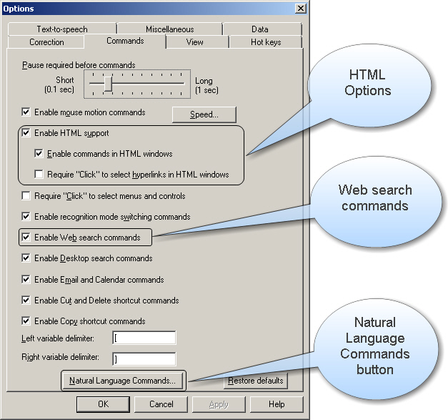

Figure : Options Dialog Box – Commands Tab

**Enable Web search commands** checkbox should be checked. (See Figure 1 above.) Enabling Web search commands allows you to search the Internet using voice shortcuts patterned on your natural speech, even when your Web browser is not open. In the default configuration, this checkbox is checked. See **Objective 6**, **Perform Search of the Web**, in this user guide for further discussion of using Dragon to perform a Web-based search.

**Natural Language Commands**. Say, "**Natural Language Commands**" or say, "**press alt n**" to activate the Natural Language Commands button. (See Figure 1 above.)

The **Enable Natural Language Commands** checkbox should be checked. (See Figure 2.) Say, "**Enable Natural Language Commands**" to mark the checkbox. This feature uses an additional eight megabytes of memory and requires that you restart your computer before it takes effect. If you disable Natural Language Commands, you can still perform all actions by voice although it will take a few extra steps. For example, if you have not enabled Natural Language Commands,"**Add to Favorites**" will display the **Add to Favorites** menu item on the second toolbar, but will not automatically display the **Add to Favorites** dialog box.

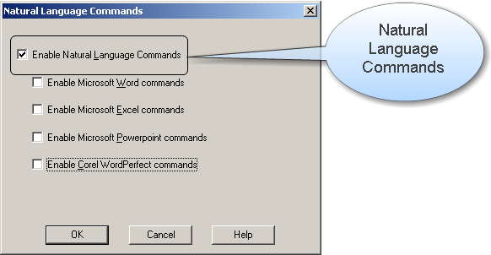

Figure : Natural Language Commands Dialog Box

#### Correction Options

Access Dragon **Correction** options (See Figure 3):

* + Say, "**switch to DragonBar**."
  + Say, "**Tools**."
  + Say, "**Options**."
  + The **Correction** tab is generally the first page displayed in the **Options** dialog box. To switch to the **Correction** tab, if necessary, say, "**Correction**."

"**Spell**" **commands bring up Spell dialog box**. (User preference). If you check this checkbox, the **Spell** dialog box will appear when you speak a spelling command ("**spell <letters>**" or "**spell that <letters>**"). If you pause after saying, "**spell**," the **Spell** dialog box is displayed even if you do not check this option.

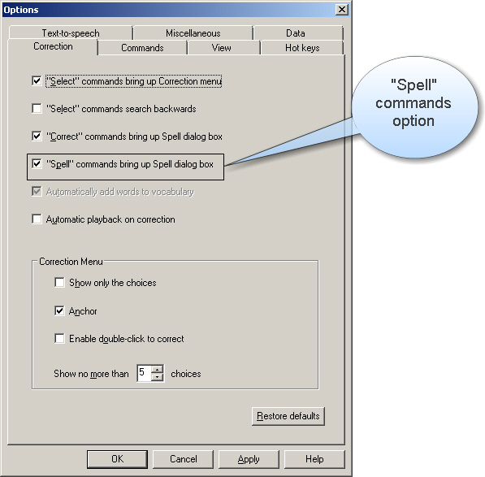

Figure 3: Options Dialog Box – Correction Tab

#### Formatting Options

Access Dragon **Formatting** options (See Figure 4):

* + Say, "**switch to DragonBar**."
  + Say, "**Tools**."
  + Say, "**Formatting**."

**Automatically format text** checkbox should be checked. The **Automatically format text** checkbox in the **Formatting** dialog box turns on different forms of automatic number and word formatting, allowing you to dictate Web addresses and e-mail addresses in a more natural way.

**Web and e-mail addresses** checkbox should be checked. If the checkbox is not checked by default, say, "**Web and e-mail addresses**"to mark the checkbox. This option allows you to dictate Web addresses in a natural manner, linking names (e.g., "SocialSecurity" instead of "Social Security") and recognizing the word "at" as the @ sign.

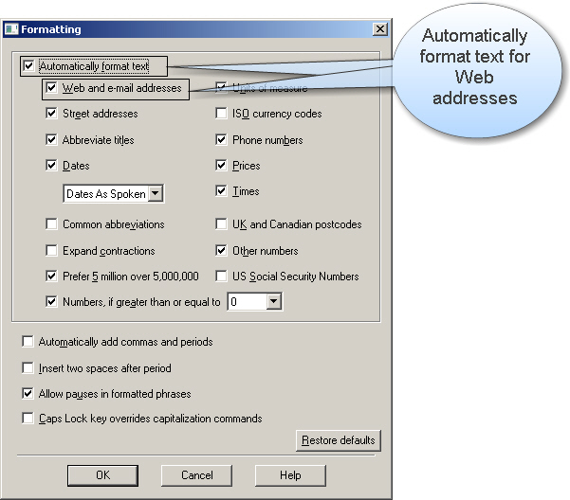

Figure 4: Formatting Dialog Box – Automatic formatting for Web addresses

# OBJECTIVE 2:

## Effectively Navigate Internet Explorer by Voice

### Navigation Command Summary

#### Summary of Navigation Commands

| **Say:** | **To:** |
| --- | --- |
| "**start Internet Explorer**" | Open Internet Explorer |
| "**go to address**" | Move the insertion point to the Address bar. |
| "**click go**"OR  "**go there**" | Go to the Web address in the Address box. |
| "**go back**" | Go back to the previous Web page. |
| "**go forward**" | Go forward to the next Web page. |
| "**go home**" | Return to your home page. |
| "**next match**" | Select the next matching link or object on the page. |
| "**previous match**" | Select the previous matching link or object on the page. |
| "**stop loading**" | Stop a Web page from loading. |
| "**refresh page**"OR  "**reload page**" | Refresh the current Web page. |

Table 2: Navigation Commands

#### Frames and Panes

When viewing a Web page that uses frames, say, "**next frame**" or "**previous frame**" to move between the different frames.

#### Scrolling Through a Page

You can use voice commands to go to the top or bottom of a page or to move up or down a screen or line at a time.

You can also start automatic scrolling by saying, "**start scrolling down**" or "**start scrolling up**." Automatic scrolling is convenient when you want to read a Web page without using the mouse or keyboard. The complete list of commands is:

| **Say:** | **To:** |
| --- | --- |
| "**go to bottom**" | Scroll to the end of the page. |
| "**go to top**" | Scroll to the beginning of the page. |
| "**page down**" | Scroll down one screen. |
| "**page up**" | Scroll up one screen. |
| "**line down**" | Scroll down one line. |
| "**line up**" | Scroll up one line. |
| "**start scrolling down**" | Start automatic scrolling toward the end of the page. |
| "**start scrolling up**" | Start automatic scrolling toward the beginning of the page. |
| "**speed up**" | Increase scrolling speed. |
| "**slow down**" | Decrease scrolling speed. |
| "**stop scrolling**" | Stop automatic scrolling. |

Table 3: Commands for Scrolling through a Web page

#### Selecting Links

You can click the text links and buttons on a Web page simply by saying the link or button name. If the text link or button name is long, you do not need to say all of it. Just say enough to distinguish it from other links on the page.

You can also say, "**click**" and then the text link. Sometimes saying, "**click**" first is more reliable than just saying the link text alone.

If more than one link matches what you said Dragon numbers all the links on the page. Say, "**choose**" with the number of the link you want. For example, say, "**choose** **2**."

**User Tip:**

On secure Web pages this feature is disabled. You cannot select links on secure pages by voice.

#### Working with Text Boxes

Say, "**type text**" to move to the first text box on the page. You may also say, "**edit box**" or "**text field**" instead of "**type text**." If the page has more than one text box, Dragon numbers them. Choose the number you want (for example, say, "**choose 2**"), or move to the next or previous text box by saying, "**next match**" or "**previous match**."

#### Working with List Boxes

To open a list box say, "**click list**," or simply "**list**."

To make a selection from an open list say the full name of the selection. You may also say, "**move down**" or "**move up**" and the number of places your selection is from the current selection (for example, say, "**move down four**" or "**down four lines**"). When you have highlighted the selection you want, say, "**close list**."

To open one of several list boxes:

If there is more than one list box visible on your screen, when you say, "**click list**" or "**list**," a series of numbered markers appears next to the possible matches.

A red marker points to Dragon's first choice.

Green markers point to additional list boxes. To open one, say, "**choose**" and the number of the marker next to the list you want to open, or simply say the number.

#### Commands for Selecting Links, Images, and Controls

The following table is a list of commands you can use for clicking links, images, checkboxes, lists, and buttons:

| **Say:** | **To:** |
| --- | --- |
| "**type text**"OR  "**edit box**" OR  "**text field**" | Number all text boxes on page and go to the first one. |
| "**click check box**"OR  "**check box**" | Number all checkboxes on the page and go to the first one. |
| "**click image**"OR  "**image**" | Number all images with links on the page and go to the first one. |
| "**choose 2**" | Select the image, option, button, or other item from the numbered list of choices. You can say any number that appears in the list. |
| "**click radio button**"OR  "**radio button**" | Number all option (radio) buttons on the page and go to the first one. |
| "**click list box**"OR  "**list box**" | Number all boxes with a list of choices (drop-down lists) on the page and go to the first one. |
| "**drop list**"OR  "**open list**" | Opens the list box to show all the choices available in the list. |
| "**close list**" | Close a list of choices. |

Table 4: Commands for Selecting Links, Images, and Controls

# OBJECTIVE 3

## Effectively Dictate Web Addresses in the Address Bar

### Dictating Web Addresses

#### Dictate Web Addresses

Dictate Web addresses as you would normally say them. Dragon automatically formats them for you, as long as you have selected "**Web and e-mail addresses**" in the **Formatting** dialog box of Dragon **Tools**.

* When you say, "**h t t p**" or "**w w w**," Dragon knows to format the words you dictate after that as a Web address.
* Say, "**dot**" to indicate separating periods (for example, "**www** **dot social** **security dot gov**").
* Say, "**com**," "**gov**," "**net**," and "**org**," as words.
* To enter Web addresses in all lowercase letters, use the "**No-Caps-On**" and "**No-Caps-Off**" commands.

**Spell Mode** may also be useful for dictating Web addresses. Say, "**spell mode on**" or "**switch to spell mode**," and then say any combination of letters, numbers or symbols. You can return to normal dictation by saying, "**spell mode off**" or "**normal mode on**."

You may also use the **Spell** command while in normal dictation mode. Say, "**spell**" followed by any sequence of letters, numbers, or symbols. Try not to pause during the sequence. If you do pause, just say, "**spell**" again before resuming your spelling. If you have selected "**'Spell' commands bring up the Spell dialog box**,"say, "**spell**," the **Spell** dialog box will open, then say any sequence of letters, numbers, or symbols.

**User Tip:**

For Web addresses you use frequently, you can create custom commands using **Text and Graphics**, **Step-by-Step**, or **Advanced Scripting** commands. You may also wish to enter frequently used Web addresses into your custom vocabulary.

# Objective 4

## Effectively Utilize Favorites to Navigate to Frequently used Web Addresses

### Utilizing Favorites

#### Add to Favorites

It is beneficial to add frequently used Web addresses to the Internet Explorer **Favorites** menu.

After accessing the desired Web address ("URL"), say, "**make a favorite**" or say, "[**go to**|**switch to**|**view**|**display**|**show**|**open**] **Add to Favorites**." The **Add a Favorite** dialog box will appear with the cursor in the name field. If the name that appears in the dialog box is acceptable, say, "**Add**." If not, dictate the name of your Favorite and then say, "**Add**."

**User Tip:**

The names you give to your Favorites are critical for successful use in opening your Favorites by voice. The name should be easily remembered, easily dictated (not too long or complex), and easily distinguished from other Favorites in your list.

If you have disabled **Natural Language Commands**,"**Add to Favorites**" will display the **Add to Favorites** menu item on the second toolbar. Say, "**press enter**" or "**press alpha**" to activate the menu item.

#### Navigate to a Favorite

To open a favorite Web page, say, "**Favorites**"or "**click Favorites**." Say the complete name of your Favorite from the visible list.

If the Favorite is in a folder, say the complete name of the folder, followed by the complete name of the Favorite.

**User Tip:**

The Favorite must be visible on the screen in order to execute the Favorite by voice. If it is not visible on the screen, say, "**move up one**" to rotate to the bottom of the list or say, "**move down <1-20>**" until the desired Favorite comes into view. Then, say the complete name of the Favorite. You may also say, "**press <a-z>**or**<1-9>**" where <a-z>or <1-9> is the first character of the desired Favorite. Repeat this process until your focus is on the desired Favorite and then say, "**press enter**."

#### Organization of Favorites

Keep your Favorites organized in folders for easier use with Dragon. As previously noted, if you keep your Favorites in a long list, it will be necessary to move up or down the list until your Favorite is visible on the screen.

To go to a Website located in a sub-folder of Favorites, say, "**Favorites**" or "**click Favorites**." Say the name of the folder and then say the complete name of the Favorite.

**User Tip:**

If Dragon is having trouble recognizing the name of your Favorite or Favorite folder, say, "**press <a-z>**or**<1-9>**" where <a-z>or<1-9> is the first character of the folder or Favorite. If you have more than one item beginning with the same character, repeat this process until your focus moves to the desired Favorite or folder.

If you are using the "**press <a-z>**or**<1-9>**" method to move through your Favorites list, there are two advantages to naming your folders or Favorites with a unique first character. First, you will only have to use your "**press**" command once to move to the desired item. Second, if the item is the only item beginning with that character, it will automatically execute without your having to give an additional command such as "**press enter**."

**Example 1:** You wish to move to a Favorite named "SSA Homepage." If "SSA Homepage" is the only item beginning with "S," when you say, "**press s**," you will automatically activate the "SSA Homepage" Favorite and go to the Web page. If "SSA Homepage" is not the only item beginning with "S," you will have to repeat the "**press s**" command until you highlight the "SSA Homepage" Favorite and then you will have to say, "**press enter**."

**Example 2:** If you wish to expand a folder named "Personal," and "Personal" is the only item beginning with "P," when you say, "**press p**," your focus will move to the "Personal" folder and it will automatically expand. If "Personal" is not the only item beginning with "P," you will have to repeat the "**press p**" command until your focus moves to "Personal" and then you will have to say, "**press enter**" or "**move right**" to expand the folder.

# Objective 5

## Effectively Utilize Tabbed Browsing

### Utilize Tabbed Browsing to Open Multiple Web Pages within the Same Browser Window

#### Tabbed Browsing in General

The tabbed browsing feature in Internet Explorer allows you to have a number of Web pages open at the same time within a single program window and move easily between these pages.

Each open Web page has a corresponding **New Tab** button on the **Command Bar** (second toolbar). When describing tabbed browsing, we often refer to the pages as tabs, as in "opening a new tab." In addition, we often refer to the page with the focus as being in the foreground, while we describe the other tabs as being in the background.

#### Opening Tabs

To open a new blank tab in the foreground, say, "**New Tab**" or say, "**press control t**." The title of the new tab is Blank Page, and is blank.

To open a new tab from the **Address Bar** or the **Search** box, say, "**New Tab**" or say, "**press alt enter**." The new tab is in the foreground.

#### Switching Between Tabs

To move to the next or previous tab, say, "**Next Tab**" or "**switch to next tab**" or say, "**press control tab**." To move to the previous tab, say, "**Previous Tab**" or "**switch to previous tab**" or say, "**press control shift tab**."

To open a menu containing titles of the tabs, say, "**Tab List**" or say, "**press control shift q**." To move to a tab, say the name of the tab or say, "**move down <1-9>**" where <1-9> moves your focus to the correct tab on the menu, and then say, "**press enter**."

To move to the first through eighth tabs, say, "**switch to tab <1-8>**" or say, "**press control <1-8>**." This works up to the eighth tab.

To move to the last tab, no matter where it is positioned in the list, say, "**switch to tab 9**" or say, "**press control 9**."

**User Tip:**

If you have not enabled **Natural Language Commands**, Dragon will not recognize the commands "**switch to tab <1-8>**" and "**switch to tab 9**." However, you can continue to use the keystroke commands "**press control <1-8>**" and"**press control 9**."

#### Closing Tabs

To close the current tab, say, "**close tab**" or say, "**press control w**" or "**press control f4**." Note that if only one tab is open, then these keystrokes also close the program.

To close all the tabs apart from the current tab, say, "**close other tabs**" or say, "**press control alt f4**."

#### Commands for Tabbed Browsing

**User Tip**:

While the following commands are standard Dragon voice commands, if Natural Language Commands are not enabled, the commands related to moving between tabs (for example, "**switch to next Tab**," "**View 2nd Tab**") are not available. Therefore, when navigating between tabs, you may wish to utilize the Dragon Keyboard Commands for Tabbed Browsing (detailed in the second table).

| **Say:** | **To:** |
| --- | --- |
| "**New Tab**" | Open a new blank page in the same browser window. |
| "**open in background tab**" | Open new tab in the background. |
| "**next tab**" | Move to the next tab. |
| "**previous tab**" | Move to the previous tab. |
| "**Tab List**" | Display a menu containing titles of all the tabs. |
| "**move to|switch to|open| show|view <1st – 8th> tab**" | Move focus to first through eighth tab. |
| "**move to|switch to|open| show|view ninth tab**" | Switch to the last tab, no matter what number it is. |
| "**close tab**" | Close the tab in the foreground. |
| "**close other tabs**" | Close all tabs but the tab in the foreground. |

Table 5: Commands for Tabbed Browsing

#### Dragon Keyboard Commands for Tabbed Browsing

| **Say:** | **To:** |
| --- | --- |
| "**press control t**" | Open a new blank page in the same browser window. |
| "**press control enter**" | Open links in a new tab in the background. |
| "**press control shift enter**" | Open selected link in a new tab in the foreground. |
| "**press control tab**" | Move to the next tab. |
| "**press control shift tab**" | Move to the previous tab. |
| "**press control shift q**" | Display a menu containing titles of all the tabs. |
| "**press control <1-8>**" | Move focus to first through eighth tab. |
| "**press control 9**" | Switch to the last tab, no matter what number it is. |
| "**press control f4**"OR  "**press control w**" | Close the tab in the foreground. |
| "**press control alt f4**" | Close all tabs but the tab in the foreground. |
| "**press alt f4**" | Close all tabs, which also closes the application window. |
| "**press alt enter**" | From the address bar, open the address in a new tab. |

Table 6: Dragon Keyboard Commands for Tabbed Browsing

# Objective 6

## Perform Search of the Web

### Utilize Dragon to Perform a Web-based Search

#### Search the Web from Anywhere

You do not have to be in an Internet Explorer browser window to search the Web. You may search the Web from anywhere using Dragon’s Web search shortcuts. You can search specific categories, such as maps, news, products, images, or videos: for example, say, "**search images for caterpillar**." You can also search using a specific search engine; for example, say, "**search Google for Social Security benefits**."

You can also search from the Internet Explorer browser window. Say, "**do a search**" or say, "**search the Web**" to move to the **type to search the web** field.

# EXHIBIT 1 – phonetic alphabet

|  |  |
| --- | --- |
| To Type: | Say, "press…" |
| a | "**alpha**" |
| b | "**bravo**" |
| c | "**Charlie**" |
| d | "**delta**" |
| e | "**echo**" |
| f | "**foxtrot**" |
| g | "**golf**" |
| h | "**hotel**" |
| i | "**India**" |
| j | "**Juliet**" |
| k | "**kilo**" |
| l | "**lima**" |
| m | "**Mike**" |
| n | "**November**" |
| o | "**Oscar**" |
| p | "**papa**" |
| q | "**Quebec**" |
| r | "**Romeo**" |
| s | "**sierra**" |
| t | "**tango**" |
| U | "**uniform**" |
| V | "**Victor**" |
| W | "**whiskey**" |
| X | "**x-ray**" |
| Y | "**Yankee**" |
| Z | "**Zulu**" |

Table 7: Phonetic Alphabet

# Exhibit 2 – General User tips

If Dragon has difficulty in recognizing a commonly used word or phrase and you have tried correcting the misrecognition at least twice, use the train word feature to teach Dragon how you pronounce it.

* Say, "**train** **word**."
* Type or dictate the desired word or phrase.
* Say, "**Go**."
* Say the word as you would normally say it. Try not to over-enunciate.
* Say, "**OK**."

In order to "train" the word, it must be part of your vocabulary. If it is not part of your vocabulary, you can add individual words to your vocabulary by using the add word feature.

* Say, "**add word**."
* Type or spell the word, and say, "**OK**."
* In the default configuration, "**I want to train the pronunciation of this word**" is enabled. It is not necessary to train every new word you add because Dragon will predict the pronunciation. If Dragon does not recognize the words correctly, you should train them. Be sure you save your user files after adding new words or you will not save the new words.

Say, "**press alt**" to close a drop down menu or move off the **Menu Bar**.

In addition to Dragon voice commands, you can speak the access keys (the underlined letter in many menus and dialog boxes) to perform many tasks. For example, say, "**Tools**" or say, "**press alt t**" to access the **Tools** menu in the **DragonBar**.

# FEEDBACK SHEET

Request to the instructor:

As you use this training package, please document errors, omissions, and revisions and notify us of any required editing. At the completion of this segment, you should mail this form to the address on the next page.

**Source of report**:

Location of training: _______________________________

Your name: _____________________________________

Your phone number: ______________________________

**Timeframes**:

How much time did it take to present this material?

**Topics**:

Is there any material in the lesson that is covered but not relevant to your position that we should remove? If so, what?

Can you identify any topic not covered in the lesson that should be included?

**Complexity level**:

Are there any lessons that appear either too simple or too complex? Which ones? Why?

**Testing**:

How would you rate the usefulness of the tests and exercises?

1 2 3 4 5

Irrelevant Adequate Quite helpful

Please note your corrections below or attach a photocopy of corrected pages.

Page # Correction Needed

**Comments**:

Use the space below for your comments on how we can improve this material.

**Mail to**:

Gregory Gill

Social Security Administration

EHR Ste 100

6401 Security Blvd.

Baltimore, MD 21235

Or e-mail comment to [gregory.gill@ssa.gov](mailto:gregory.gill@ssa.gov?subject=Training%20Material%20Feedback)